**AFFILIATION MANAGEMENT SYSTEM**

# User Manual

Version 1.0

**Table of Contents**

1. Introduction 1

2. Purpose of User Manual 2

3. Affiliation Branch Portal 3

3.1 Affiliation Branch Dashboard 3

3.2 How to Register New Institution Account on Portal 3

3.3 Login 3

4. Affiliation Committee Member Portal 3

4.1 Login 3

5. Institute Portal 3

5.1 Login 3

1. **Introduction**

The objective of introducing affiliation management system is to purified more wastage of timethat are consumed in the paper work as well as it overcomes the problem to store large amount of data. Mostly institute face problems while they came to university for submitting their affiliation form. The affiliation management system is handle the problems that occur in affiliation. But now this application we develop for the institutions and university that now institutes can submit their applications online. Once the institute submit its application then committee members give feedback to its application, on the basis of their feedback application assign a seat to the institute according to the program for which they applied.

1. **Purpose of User Manual**

The purpose of creating user manual is to deliver the portrayal of the project which explains how to use the application to operate the affiliation system from every aspect. Any user who would read this manual would be able to operate the affiliation system effortlessly.

1. **Affiliation Branch Portal**
   1. **Affiliation Branch Dashboard**

* Admin click on Pending application for check pending application.
* Admin click on Manage Visit for assigning dates to the committee members.

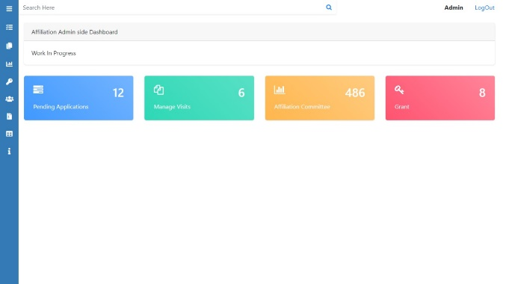

* Admin click on Affiliation Committee. After click on affiliation committee admin can see the list of affiliation committee members.
* Admin click on Grant for checking the accepted application.
  1. **How to Register New Institution Account on Portal**
* Admin click on New Institution Login. After click on it Registration form is open.
* Admin have to enter the details in the required fields. See the below form.

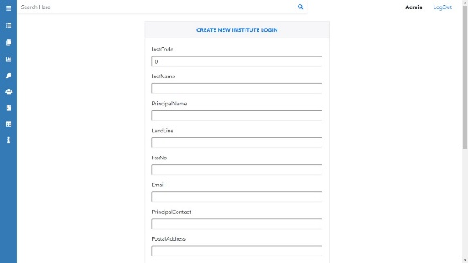

* InstCode: admin enter institution code.
* InstName: admin enter institution name.
* PrincipalName: admin enter principal name.
* LandLine: admin enter land line number.
* FaxNo: admin enter institution fax number.
* PrincipalContact: admin enter principal contact number.
* 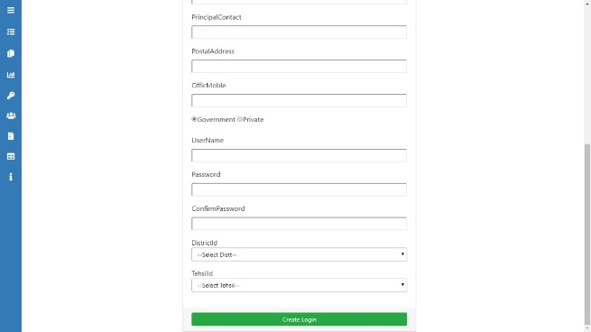PostalAddress: admin enter postal address.
* OfficeMobile: admin enter office mobile.
* Select institute is Government or Private.
* UserName: admin enter user name.
* Password: Enter password.
* ConfirmPassword: Re-enter password.
* Select District.
* Select Tehsil.
  1. **Login**
* 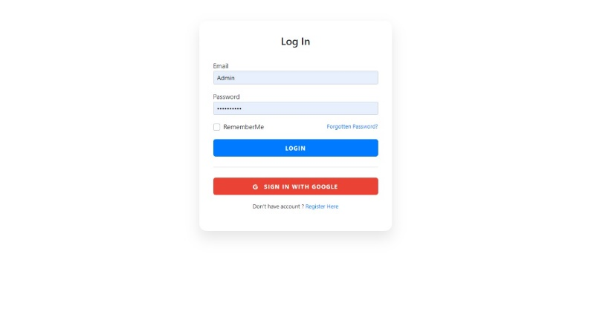Admin click on Login. After click on it login form is open.
* Email: admin enter his/her email.
* Password: admin enter his/her password.
* If admin forgot password. By clicking on Forgot Password he/she can change the password.
* If admin is not registered he/she can register himself.

1. **Affiliation Committee Member Portal**
   1. **Login**

* 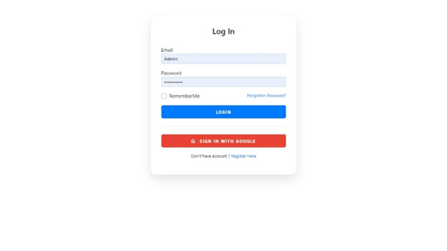Affiliation Committee Member click on Login. After click on it login form is open.
* Email: affiliation committee member enter his/her email.
* Password: affiliation committee member enter his/her password.
* If affiliation committee member forgot password. By clicking on Forgot Password he/she can change the password.

1. **Institution Portal**
   1. **Login**

* ****Institution click on Login. After click on it login form is open.
* Email: institution enter his/her email.
* Password: institution enter his/her password.
* If institution forgot password. By clicking on Forgot Password he/she can change the password.